KINECT SENSOR BASED ABNORMAL MOVEMENTS OF ELDERLY PATIENT MONITORING SYSTEM

## A PROJECT REPORT

***Submitted by***

|  |  |  |
| --- | --- | --- |
| **SASIDHARAN A** | **-** | **611221106093** |
| **JANAKAN S** | **-** | **611221106047** |
| **JANARTHANAN S** | **-** | **611221106049** |
| **ARISHKUMAR N** | **-** | **611221106009** |

***in partial fulfillment for the award of the degree of***

# BACHELOR OF ENGINEERING

***in***

**ELECTRONICS AND COMMUNICATION ENGINEERING**

**KNOWLEDGE INSTITUTE OF TECHNOLOGY (AUTONOMOUS)**

**KAKAPALAYAM, SALEM-637504**

# ANNA UNIVERSITY:: CHENNAI 600 025

## MAY 2025

ANNA UNIVERSITY: CHENNAI - 25

# BONAFIDE CERTIFICATE

Certified that this project report **“KINECT SENSOR BASED ABNORMAL MOVEMENTS OF ELDERLY PATIENT MONITORING SYSTEM”** is

the bonafide work of **“SASIDHARAN A, JANAKAN S, JANARTHANAN S, ARISHKUMAR N”** who carried out the project work under my supervision.

|  |  |
| --- | --- |
| **SIGNATURE** | **SIGNATURE** |
| Dr.V.Saravanan, M.E., Ph.D. | Mrs.L.Chitrappaavai, M.E., |
| **HEAD OF THE DEPARTMENT** | **SUPERVISOR** |
| Associate Professor | Assistant Professor |
| Department of Electronics and | Department of Electronics and |
| Communication Engineering | Communication Engineering |
| Knowledge Institute of Technology | Knowledge Institute of Technology |
| Kakapalayam | Kakapalayam |
| Salem-637 504. | Salem-637 504. |

Submitted for the University Viva Voce held on ……………

## INTERNAL EXAMINER EXTERNAL EXAMINAR

**DECLARATION**

We,

|  |  |  |
| --- | --- | --- |
| **SASIDHARAN A** | **-** | **611221106093** |
| **JANAKAN S** | **-** | **611221106047** |
| **JANARTHANAN S** | **-** | **611221106049** |
| **ARISHKUMAR N** | **-** | **611221106009** |

Declare that the project report on “**KINECT SENSOR BASED ABNORMAL MOVEMENTS OF ELDERLY PATIENT**

**MONITORING SYSTEM**” is the result of the original work done by us and to the best of our knowledge, similar work has not been submitted earlier to Anna University, for fulfillment of the requirement of the course of study.

This project report is submitted on partial fulfillment of the requirement for all awards of the degree of Bachelor of Engineering (B.E) of Anna University.

## NAME SIGNATURE

***SASIDHARAN A JANAKAN S JANARTHANAN S ARISHKUMAR N***

Place: Salem Date:

# ACKNOWLEDGEMENT

We render our special thanks to **Dr. J. Kumar**, **M.Tech. [IIT-M], Ph.D., FIE.,** Secretary Knowledge Institute of Technology Trust, for his kind and great patronage.

We render our special thanks to **Dr. PSS. SRINIVASAN, M.Tech [IIT-B], Ph.D.,** Founder, President & Executive Chairman, Knowledge Institute of Technology, who has been a bastion of moral strength and a source of incessant encouragement to us.

We take the privilege to express our profound thanks to our beloved Principal, **Dr. K. VISAGAVEL, M.E., Ph.D., FIE.,** Knowledge Institute of Technology, for providing excellent facilities made in our department to carry out this project.

We express our sincere thanks to Director, Research and Development, **Dr. N. SANTHIYAKUMARI, M.Tech., Ph.D.,** and Head of the Department, Electronics and Communication Engineering, Knowledge Institute of Technology, **Dr. V. SARAVANAN, M.E., Ph.D.,** for their valuable guidance and suggestions.

We express our thanks to our project co-ordinator, **Mr. R. SHANMUGASUNDARAM, M.E.,** Assistant Professor and our supervisor **Mrs. L. CHITRAPPAAVAI, M.E.,** Assistant Professor, Electronics and Communication Engineering for their valuable suggestions and excellent guidance through the course of our project.

We thank our beloved parents, teaching and non-teaching staff members for their valuable suggestions for completion of the project successfully.

IV

# TABLE OF CONTENTS

|  |  |  |
| --- | --- | --- |
| **CHAPTER No.** | **TITLE** | **PAGE No.** |
|  | **ABSTRACT** | viii |
|  | **LIST OF FIGURES** | ix |
|  | **LIST OF ABBREVIATIONS** | x |
| 1 | **INTRODUCTION** | 1 |
|  | 1.1 Overview | 1 |
|  | 1.2 The Potential of Depth-Sensing Technology | 2 |
|  | * 1. Background and Significance   2. Contributions of Our Project | 4  6 |
|  | 1.5 Outline of Our Project | 7 |
| 2 | **LITERATURE SURVEY** | 8 |
|  | 2.1 Development of a Communication Robot System | 8 |
|  | * 1. A Small LED Cane for Monitoring | 8 |
|  | 2.3 Detecting Depression-Related Movement Changes | 9 |
|  | 2.4 IoT-Based Elderly Monitoring System | 10 |
|  | 2.5 Wearable Health Technology for older Adults | 11 |

|  |  |  |
| --- | --- | --- |
| 3 | **PROJECT METHODOLOGY** | 12 |
|  | 3.1 Existing System | 12 |
|  | 3.2 Block Diagram | 13 |
|  | 3.3 Hardware Requirements | 13 |
|  | 3.4 Kinect Sensor XBOX 360 | 14 |
|  | 3.4.1 Kinect Sensor Components | 15 |
| 3.4.2 Kinect Sensor Process | 17 |
| 3.4.3 Kinect Skeletal Tracking | 19 |
| 3.5 Software Components and Algorithms | 23 |
| 3.5.1 Kinect SDK and Data Acquisition | 23 |
| 3.5.2 Skeletal Tracking and Data Processing | 24 |
| 3.5.3 Fall Detection Algorithm | 24 |
| 3.5.4 Out-of-Coverage Detection Algorithm | 26 |
| 3.5.5 Server-Side Application Logic | 26 |
| 3.5.6 Mobile Application Development | 27 |
| 4 | **HARDWARE AND SOFTWARE DESCRIPTION** | 29 |
|  | 4.1 Hardware Setup and Calibration | 29 |
| 4.2 Software Development Environment | 30 |
| 4.3 Visual Studio | 31 |
| 4.3.1 Introduction to Visual Studio | 31 |

|  |  |  |
| --- | --- | --- |
|  | 4.3.2 Core Components | 32 |
|  | 4.3.3 Key Features for Code Development | 34 |
|  | 4.3.4 Building and Debugging Applications | 35 |
|  | 4.4 Supporting for Different Project Types | 37 |
| 4.5 Customization and Personalization | 37 |
| 4.6 Setting Up C++ Environment | 39 |
| 4.7 Python Programming Introduction | 41 |
| 5 | **RESULTS AND DISCUSSIONS** | 45 |
|  | 5.1 Data Collection Procedures | 45 |
|  | 5.2 Performance Metrics | 45 |
|  | 5.3 Experimental Results and Analysis | 45 |
|  | 5.3.1 Fall Detection Performance | 47 |
| 5.3.2 Out-of-Coverage Detection Performance | 47 |
| 5.3.3 Alert System Performance | 47 |

|  |  |  |
| --- | --- | --- |
| 6 | **CONCLUSION AND FUTURE SCOPE** | 48 |
|  | 6.1 Conclusion | 48 |
|  | 6.2 Future Scope | 48 |
|  | **REFERENCES** | 49 |
|  | **PUBLICATIONS** | 51 |

**ABSTRACT**

This project demonstrates a real-time fall detection system using the Microsoft Kinect depth sensor, aimed at non-invasive monitoring of at-risk individuals. The system uses 3D skeletal tracking to monitor postural changes and movement patterns, with a strong algorithm to differentiate between normal activities, out of camera coverage zones and falls. When it senses a fall, the system sends an alert system, illustrating the capability of Kinect technology in applying proactive safety systems in elderly care and healthcare facilities. For rapid response, the sensed fall event initiates an alert message delivered to a receiver through a server to user mobile application such as Telegram. This application is set up with Wi-Fi connectivity, sends the alert notification, such as user identification, across a network to a remote monitoring device or caregiver's mobile app. This combination of real-time fall detection and also identifies elder person exited the coverage areas with instant alert notification increases the effectiveness of the system in delivering timely assistance, reducing the possible effects of falls.

# LIST OF FIGURES

|  |  |  |
| --- | --- | --- |
| **FIG. No.** | **NAME OF THE FIGURE** | **PAGE No.** |
| 3.1 | BLOCK DIAGRAM | 13 |
| 3.2 | OVERVIEW OF KINECT SENSOR | 14 |
| 3.3 | PROCESS OF KINECT SENSOR | 18 |
| 3.4 | SKELETAL TRACKING USING KINECT | 20 |
| 3.5 | PIPELINE OF KINECT SKELTAL TRACKING | 21 |
| 4.1 | VISUAL STUDIO IDE INTERFACE | 32 |
| 4.2 | DEBUGGING SESSION WITH BREAKPOINTS | 36 |
| 4.3 | LIST OF AVAILABLE PACKAGES IN C++ | 40 |
| 5.1 | SIMULATION OUTPUT | 53 |
| 5.2 | TELEGRAM NOTIFICATION | 53 |

# LIST OF ABBREVIATIONS

|  |  |  |
| --- | --- | --- |
| **S.No.** | **ABBREVIATION** | **FULL FORM** |
| 1 | AI | Artificial Intelligence |
| 2 | CPU | Central Processing Unit |
| 3 | GUI | Graphical User Interface |
| 4 | IoT | Internet of Things |
| 5 | SDK | Software Development Kit |
| 6 | RGB | Red Green Blue |
| 7 | USB | Universal Serial Bus |
| 8 | UI | User Interface |
| 9 | API | Application Programming Interface |
| 10 | ML | Machine Learning |
| 11 | FPS | Frames Per Second |
| 12 | MS | Microsoft |
| 13 | Wi-Fi | Wireless Fidelity |
| 14 | PC | Personal Computer |
| 15 | FFT | Fast Fourier Transform |
| 16 | LCD | Liquid Crystal Display |
| 17 | 3D | Three-Dimensional |

**CHAPTER 1**

## INTRODUCTION

## 1.1 Overview

Falls and independent wandering of frail individuals, especially the elderly and cognitively impaired, are of great risk to their health and wellbeing. Conventional monitoring approaches are marred by drawbacks including intrusiveness, poor user compliance, and slow response times. In an effort to overcome these, this project introduces an in-real-time, non-intrusive monitoring solution utilizing the Microsoft Kinect depth sensor. Using 3D skeletal tracking, the system evaluates posture changes and movement patterns to properly identify both abrupt fall events and situations when a person leaves previously set safe areas of monitoring.

The system is constructed with enhanced high-fall depth algorithms with the ability to differentiate between normal indoor activities, sideward exits out of the sensor's field of view, and heavy fall occurrences. The Kinect depth sensor is constantly collecting depth information, which is subsequently analyzed to deliver skeletal tracking data. This information is input to detection algorithms that are trained to recognize certain patterns of motion related to falls—like sudden height changes, abrupt body orientation changes, or loss of a monitored person from the area. This two-stage detection approach provides improved safety by providing more complete coverage for vulnerable people.

Upon the detection of either a fall or an out-of-coverage event, the system initiates an immediate alert mechanism. This alert is transmitted via a server to a designated user's mobile application, such as Telegram. The notification includes crucial information like user identification and a timestamp of the event, enabling caregivers or emergency responders to be informed promptly. This seamless integration of real-time detection with instant mobile notifications significantly

reduces response times, potentially mitigating the severity of injuries resulting from falls or the dangers associated with unsupervised wandering.

The system's deployment provides a number of important benefits over current alternatives. The Kinect sensor is non-invasive, encouraging user acceptance and comfort at the price of a higher compliance rate. The 3D skeletal tracking offers richer and more precise movement information than basic wearable sensors. In addition, the combination of both out-of-coverage detection and falls within one platform provides a more comprehensive solution for safety monitoring. The employment of an easily accessible mobile app for alerts guarantees prompt and easy communication with caregivers.

In summary, this project shows how advanced depth-sensing technology, coupled with smart algorithms and network connectivity, can be used to develop a simple yet powerful real-time monitoring system. Through accurate detection of falls and out-of-coverage incidents and prompt alerting, the system hopes to increase the safety, well-being, and independence of at-risk individuals over traditional monitoring method.

### The Potential of Depth-Sensing Technology

Depth sensing technology, represented by sensors such as the Microsoft Kinect, has also proven to be a revolutionary instrument with broad appeal in numerous applications, most notably in healthcare and ambient assisted living. As opposed to standard 2D cameras that sense just color and intensity, depth sensors offer a three-dimensional comprehension of the world and the objects present in it. This ability presents new possibilities for spatial relationships to be analyzed, movements followed with higher precision, and human posture and gestures sensed in a non-contact fashion. This radical change from 2D to 3D perception is the foundation of many of today's groundbreaking applications designed to increase safety, well-being, and human-machine interaction.

In healthcare, the non-invasive nature of depth-sensing technology presents an exclusive advantage over traditional monitoring. Worn sensors, though effective in some situations, can be invasive and require user compliance, which might be challenging for certain populations. Depth sensors can, on the other hand, be employed remotely, gathering essential data without necessitating the individual to wear any device. This is particularly beneficial for continuous monitoring of vulnerable individuals in their homes or care facilities so that unobtrusive observation of activities, the detection of abnormalities like falls, and analysis of patterns of movement for rehabilitation are possible. This contactless approach also minimizes the risk of skin irritation and discomfort, resulting in greater levels of user acceptance and compliance with monitoring regimes.

Furthermore, the rich spatial information provided by depth sensors enables the development of sophisticated algorithms for analyzing human behavior and detecting critical events. For instance, by tracking the 3D positions of key skeletal joints, systems can identify subtle changes in posture and movement that precede a fall or indicate that an individual has moved outside a designated safe area. The ability to analyze the speed, direction, and height of movements in three dimensions allows for more robust and accurate detection compared to systems relying solely on 2D video analysis. This enhanced understanding of spatial dynamics paves the way for more reliable and context- aware monitoring systems that can differentiate between normal activities and potentially dangerous situations with greater precision.

Outside fall and out-of-coverage identification, the future of depth- sensing technology also lies in several other health care applications. It can be applied for distant rehabilitation by monitoring patients' movement patterns while performing exercises and offering them feedback about their posture. It

can be used to support sleep monitoring by evaluating body movements and restlessness with no need for painful wearables. In addition, depth sensors can play a role in human-computer interaction in assistive technologies to bring gesture-based control to people of limited mobility. As the tech advances and price and power demands decrease, we can expect this technology to penetrate smart homes and healthcare settings at large, altering the way that we track health, provide for safety, and improve the lives of many groups of people.

### Background and Significance

### Background

Falls are a major public health problem worldwide, particularly among older people. The World Health Organization (WHO) recognizes fall as one of the leading causes of unintentional injury and death in people aged 65 years and older. Falls have a tendency to result in severe physical injuries like fractures, head trauma, and soft tissue injuries, leading to prolonged hospitalization, increased healthcare costs, and a significant loss of quality of life. Aside from physical consequences, falls also lead to a heightened fear of falling and subsequent decreased mobility, social withdrawal, and reliance on caregivers. This creates a vicious circle of frailty and increased risk for falls, underscoring even more the imperative of proper prevention and detection mechanisms.

Beyond falls, the issue of individuals, especially those with cognitive impairments like dementia or Alzheimer's disease, wandering away from safe environments poses another significant challenge. This behavior can lead to dangerous situations, including exposure to harsh weather conditions, traffic accidents, and difficulty in locating the individual, causing immense stress and anxiety for caregivers and families. The increasing prevalence of these conditions, coupled with the desire to maintain independence for as long as possible, underscores the critical need for unobtrusive and reliable monitoring

systems that can not only detect falls but also identify when an individual has moved outside designated safe zones, enables timely intervention and preventing potentially life-threatening situations.

### Significance

The development of an accurate and real-time fall and out-of-coverage detection system holds significant potential for improving the lives of vulnerable individuals and alleviating the burdens on their caregivers and the healthcare system. Early detection of falls allows for immediate assistance, potentially reducing the severity of injuries and improving recovery outcomes. Similarly, the ability to detect when an individual has wandered outside safe areas enables timely intervention, preventing potentially dangerous situations and providing peace of mind to caregivers. By offering a non-invasive and automated monitoring solution, this technology can contribute to maintaining independence and promoting a greater sense of security for at-risk individuals in their own homes or care facilities.

Further, the integration of an easily accessible mobile notification system enhances the effectiveness and value of such a care monitoring system. Notification nearly in real time to caregivers or appropriate responders can facilitate timely action, which could prevent the distressing consequences of a fall or wandering episode. The capacity for prompt response is perhaps particularly crucial to avoid detrimental consequences from a fall or wandering incident. Through the use of low-cost and pervasive technologies like the Kinect sensor and commodity mobile communication, this project aims to provide a scalable and affordable solution that can be readily adopted in various healthcare and homecare settings, thus resulting in a more responsive and proactive care environment.

### Contributions of our project

These are some of the possible contributions of our project, centered on designing a real-time out-of-coverage and fall detection system through the use of the Kinect and mobile notifications:

1. Integrated Non-Invasive Monitoring Solution

This project presents a novel, non-invasive system that uniquely integrates real-time fall detection and out-of-coverage detection within a single platform utilizing the Kinect depth sensor. This offers a more comprehensive safety net compared to systems that focus solely on one type of event or rely on intrusive wearable sensors.

1. Enhanced Detection Accuracy through 3D Skeletal Analysis

The system leverages the Kinect's 3D skeletal tracking capabilities to develop robust algorithms for both fall and out-of-coverage detection. By analyzing detailed postural changes and movement patterns in three dimensions, the system aims to achieve higher accuracy and reduce false alarms compared to methods relying on 2D video or simpler motion sensors. The algorithms are specifically designed to differentiate between normal activities, movements outside the monitored area, and actual fall events.

1. Real-time Alert System with Mobile Integration

The project implements a practical and efficient real-time alert system that notifies designated caregivers or responders immediately upon the detection of a fall or an out-of-coverage event. The integration with a readily accessible mobile application (e.g., Telegram) via a server ensures timely communication, enabling prompt assistance and potentially mitigating the adverse consequences of these incidents.

1. Improved Response Time and Caregiver Burden Reduction

Through automating the process of detection and alerting, it is possible to reduce response times dramatically in instances of an emergency. This may lead to better outcomes for patients who have fallen or wandered off.

1. Scalable and Cost-Effective Monitoring Solution

The system employs the comparably inexpensive and readily available Microsoft Kinect sensor and takes advantage of standard network communication for alert forwarding. The methodology is designed to offer a low-cost, scalable monitoring solution easily implementable across different homecare and healthcare environments, enhancing accessible advanced safety monitoring.

### Outline of our project

* **Section 1** discusses current patient monitoring systems and defining their shortcomings in the areas of precision, and alert notification mechanisms.
* **Section 2** details the proposed system architecture, including the selection of components such as the Microsoft Kinect depth sensor and the server infrastructure for data processing and alert management, as well as the mobile application (e.g., Telegram) for receiving alerts.
* **Section 3** outlines the software environment applied in system development, such as the Kinect SDK and programming languages applied for implementing algorithms (e.g., Python, C++).
* **Section 4** describes the outcome of the system tests, comprising the efficacy of fall detection and out-of-coverage detection algorithms, alert notification system reliability to the mobile app, and its performance in diverse environmental conditions and user activity.

# CHAPTER 2 LITERATURE SURVEY

## DEVELOPMENT OF A COMMUNICATION ROBOT SYSTEM FOR MONITORING OLDER PEOPLE

*Yoshiyuki Takahashi, Motoki Takagi, Kaoru Inoue,2019*

In Japan, the progressive decline in the population of people of working age has created difficulties to provide a high quality of care for older individuals. In order to overcome this issue, we will introduce a communication robot system to supervise older individuals who reside alone. The robot system is designed to alleviate the care burden of care workers and preserve older people's cognitive function and social connections. This article presents the characteristics of our monitoring and communication robot system, its operation, and the application of natural conversation.

### Drawbacks

* + - However, to develop a simple conversation system by ourselves results in no system freely modified and an inexpensive system.

## A SMART LED CANE TO MONITOR OLDER PEOPLE LIVING ALONE FOR CONSIDERING PRIVACY

*Kohichi Ogawa,2022*

In recent years, the number of older people living alone has increased in Japan. Older people living alone may suddenly require urgent medical attention or treatment. However, some people in this population may not be able to monitor their physical condition; naturally, some abnormalities can only be observed by others. A wide variety of monitoring systems have been developed. This study considers cases in which older people living alone may experience a medical emergency and require urgent care. We propose a method in which an accelerometer is attached to a cane to collect behavioral data and display it with

LED indicators. To avoid privacy violations, the LED display is read by a camera positioned so as not to be visible to people other than the user. We developed an implementation of the cane and confirmed the issues involved in the experiment. Research on this project is ongoing at present.

### Drawbacks

* + - This smart LED cane device needs more maintenance and also required more time to detect abnormalities.

### Detecting Depression-related Movement Changes in Older Adults using Smart Home Motion Sensors - A Feasibility Study

*Deepa Prabhu, Mitchell Dennis, Mahnoosh Kholghi, Wei Lu, Moid Sandhu, Katie Packer, Julia Bomke, Liesel Higgins, Qing Zhang and David Silvera- Tawil,2023*

Smart home sensor data is being increasingly used to identify health risks through passive tracking of specific behaviors and activity patterns. This study explored the feasibility of using motion sensor data to track changes in daytime movement patterns within the home, and their potential association with depression in older adults. This study analyzed the motion sensor data collected during a one-year smart home trial, and explored their association with Geriatric Depression Scale (GDS) scores collected at three different time points during the trial (i.e., baseline, mid-trial, and end-trial). Our results showed that movement patterns are generally reduced when older adults are in a depressed state compared to when being in a not-depressed state. In particular, the reduced movement activity in depressed states was significant (p<.05) when the participant’s GDS state changed between depressed and not-depressed for the first time during the three time points of the trial when GDS was collected.

Clinical relevance— Our results establish the feasibility and potential use of motion sensor data from ambient sensors in a smart home for passive and

remote assessment of older adults’ depression status, that is comparable to their GDS scores, through changes in their in-home day-time movement patterns. Also, since reduced movement activity may be a general indicator of potential health risks, this study provides preliminary evidence for using in-home movement activity monitoring as a general indicator of health risks.

### Drawbacks

* + - Though when reduced activity is detected, then it is contributed as a depression but not accurately.

## IOT BASED ELDERLY MONITORING SYSTEM

*S. Deepika, K. P. Vijayakumar,2022*

As the number of older people grows, the demand for their health checkup as well as for monitoring their day-to-day activities increases. By 2050, India will have over 319 million older individuals, three times more than the 2011 census, as per India's Longitudinal Aging Survey (LASI). The percentage share of the older adult population in the total population is projected to increase from 8.6% in 2011 to 10.1% in 2021 to 13.1% in 2031. With the sudden growth in demand for elderly people monitoring numerous ideas and apps came into consideration but only some of them became successful. IoT is the most used monitoring among this generation. Accordingly, an exploration of application areas of IoT for elderly care systems that enable surveillance of seniors remotely is being centered on here. It further classifies the application into two sides like IoT based Video Monitoring Surveillance and surveillance based on Wearable Sensors.

### Drawbacks

* + - Consequently, wearables sensors are difficult to wear device always which results it is not friendly distant monitoring, not supportive system for independent living.

## LONG-TERM EFFECTS OF WEARABLE HEALTH TECHNOLOGY AND FUTURE MHEALTH USAGE FOR OLDER ADULTS

*X. Gu1, X. Chang,2024*

This study is to verify wearable health technology (WHT)’s long-term effects on older adults’ health and lifestyle management, and to propose the strategies for future usage of mHealth to meet older adults’ needs. This is a two- year follow-up study for the previous 12- week WHT trial. Twenty-four older adults in the previous trial agreed to participant in this semi-structured interview study. Three patterns of older adult users’ health awareness changes were identified: no change-consistent low (n=2), no change-consistent high (n=7), and increased (n=15). Owe to the increased awareness because of the 12-week WHT trial, long-term behavior changes were identified for their health and lifestyle improvements in the following two years. To achieve a healthier lifestyle, their attentions were paid not only on physical activity, but also on well-balanced diet and sleep rhythm. Therefore, the long-term effects of WHT were proved. To support the self-health and lifestyle management, 10 participants used various technologies along with own needs and convenience, such as mobile apps and home medical devices. Regarding the future mHealth usage, older adults emphasized the recognition of mHealth technologies’ benefits. In addition, connecting mHealth technology like mobile apps with home medical devices were also expected.

### Drawbacks

* + - However, although most of the elder user-unfriendly concerns were pointed out and expected improvement.

# CHAPTER 3

## PROJECT METHODOLOGY

### Existing System

Microsoft Kinect, initially developed for gaming on the Xbox console, has evolved into a powerful motion-sensing device widely adopted in healthcare and research. It uses structured infrared light and depth sensing to create a 3D model of its environment and can detect and track up to 25 skeletal joints of a human body. This real-time skeletal tracking capability has made Kinect a popular choice for non-contact fall detection systems, physical therapy monitoring, and gesture recognition applications.

In traditional monitoring systems, elderly individuals are often required to wear sensors or manually trigger alarms, which may not be feasible in emergency situations. Kinect overcomes this limitation by offering a non-intrusive monitoring approach that does not rely on physical contact. Its ability to continuously track body posture, position, and movement in 3D allows it to detect abnormal behavior such as sudden falls or loss of stability without the need for wearables. This enhances both user comfort and system reliability in elderly care environments.

Many existing fall detection systems utilize Kinect’s skeletal tracking for identifying critical events like falls. These systems often use rule-based algorithms or machine learning techniques to analyze joint positions and movements in real-time. Falls are typically identified based on rapid vertical displacement of the torso or head, followed by a period of inactivity. Kinect’s high-resolution depth data and frame rate support accurate and timely recognition of such events, helping reduce false positives and ensuring that caregivers are alerted promptly.

Kinect-based monitoring systems provide a non-contact, accurate, and real-time method for detecting falls and monitoring elderly individuals. Its ability to track skeletal movements without wearables offers significant advantages in comfort, compliance, and effectiveness. Existing systems have demonstrated its utility in both standalone and integrated setups. As the technology continues to advance, Kinect remains a valuable component in smart healthcare solutions, especially in fall detection and elderly care applications.

### Block Diagram

Kinect sensor

**PC/ Laptop**



**Mobile**

**Fig. 3.1** Block Diagram

### Hardware Requirements

* Kinect Sensor XBOX 360
* Power Adaptor with USB
* PC/Laptop

### Kinect Sensor XBOX 360

Microsoft's Kinect depth camera, first made available in 2010 as a motion-sensing input accessory for the Xbox 360 console, transformed human- computer interaction by making experience possible without a controller. In essence, Kinect relies on an advanced blend of hardware and software to sense the three-dimensional environment. This technology goes far beyond gaming, having important applications across many fields, such as healthcare, robotics, and human-computer interaction research, especially in applications such as patient monitoring. The Kinect sensor uses a number of sophisticated sensing hardware. Notably, it has a depth sensor, a color camera, and a four-microphone array that yield full-body3D motion capture, facial recognition, and voice recognition features.

The depth-sensing capability of the Kinect is achieved through a clever and cost-effective design involving an **infrared (IR) projector** and an **IR depth sensor (camera)**. The IR projector emits a structured light pattern, typically a grid of dots, onto the scene. This pattern, invisible to the human eye, is then captured by the IR depth sensor.

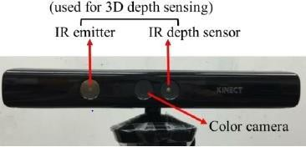

**Fig. 3.2** Overview of Kinect Sensor XBOX 360

* **Non-Contact Interaction:** The primary advantage is its ability to track movement and perceive depth without requiring users to wear or hold any physical devices.
* **Structured Light Technology:** The first-generation Kinect primarily employed structured light, projecting an IR pattern and analyzing its distortion to calculate depth.
* **Components:** The sensor unit houses an RGB camera, an IR emitter (projector), an IR depth sensor (camera), and a multi-array microphone.
* **Beyond Gaming:** While initially for gaming, its affordability and capabilities made it popular for research and other applications.
* **3D Perception:** The depth sensor allows the system to "see" the environment in three dimensions, crucial for understanding spatial relationships and tracking body movements.

### Kinect Sensor Components

The **IR projector** utilizes an infrared laser that passes through a diffraction grating to create the structured light pattern. When this pattern hits objects in the scene, the distortions in the pattern as viewed by the **IR depth sensor** are analyzed. The relative positions of the projector and the sensor are fixed and known. By triangulating the observed distortions in the IR dot pattern, the system can calculate the depth (distance) of each point in the scene. Areas closer to the sensor will exhibit a different pattern distortion compared to those farther away.

The **depth image** generated by the Kinect is a grayscale image where the intensity of each pixel corresponds to the distance of that point from the sensor. Closer objects appear brighter, while farther objects appear darker. This depth information, combined with the skeletal tracking algorithms developed by Microsoft and the research community, allows for robust analysis of human posture and movement. The Kinect can track multiple individuals simultaneously, identifying key joints and their 3D positions in real-time.

* + - * **IR Pattern Distortion:** Depth is computed from the distortion of the projected infrared dot pattern viewed by the IR camera.
      * **Triangulation Principle:** Known geometry between the IR projector and sensor enables calculation of depth based on observed pattern distortion.
      * **Depth Image:** Depth sensor output is a grayscale image where distance is represented, and closer objects are brighter pixels.
      * **Skeletal Tracking:** Sophisticated software algorithms can analyze the depth data to identify and track the 3D positions of human joints.
      * **Multi-Person Tracking:** The Kinect can typically track multiple individuals within its field of view simultaneously.

The depth sensor is comprised of the IR projector and the IR camera, which is a monochrome complementary metal-oxide semiconductor (CMOS) sensor. Even though the actual technology is not revealed, it is on the principle of structured light. The IR projector is an IR laser that travels through a diffraction grating and becomes an array of IR dots. The relative geometry between the IR camera and the IR projector and the pattern of projected IR dots are known. If we can find a match between a dot seen in an image and a dot in the projector pattern, we can reconstruct it in 3D through triangulation. Since the dot pattern is quite random, the correspondence between the IR image and the projector pattern can be established in a simple manner by comparing small neighborhoods using, for instance, normalized cross correlation.

The value of depth is stored in the form of gray values; the darker the pixel, the closer the point is to the camera in space. The black pixels are used to signify that no depth values are available for these pixels. This could occur if the points are too distant (and the depth values cannot be calculated correctly), are too proximal (there is a blind area due to small fields of view for the projector and the camera), are in the cast

shading of the projector (there are no IR dots), or reflect bad IR lights(such as hair or specular surfaces).The depth values generated by the Kinect sensor are occasionally erroneous because the IR projector to IR camera calibration becomes invalid. This may due to heat or vibration during shipping or an IR laser drift. In order to solve this issue, along with the Kinect team, came up with a recalibration method.

If the users notice that the Kinect is not registering their movements correctly, they can reset the Kinect sensor using the card. The concept is a variation of my previous camera calibration method. The depth value generated by the Kinect sensor is taken to be an affine transformation of the actual depth value—that is,

Zmeasured = αZtrue+β

which we discovered was a fairly decent model. The purpose of recalibration is to find α and β.

With the RGB camera, there calibration method calculates the 3D coordinates of the feature points on the calibration card in the coordinate system of the RGB camera, taken to be the actual values. Concurrently, the Kinect sensor also gives the measured 3D coordinates of those feature points in the coordinate system of the IR camera. Reducing the distances of the two point sets, the Kinect sensor is able to estimate a and b and the rigid transformation from the RGB camera to the IR camera.

### Kinect Sensor Process

The provided below image illustrates a data processing pipeline for analyzing human movement captured by a Kinect sensor, likely for action recognition or pose estimation. The process begins with the Kinect sensor acquiring raw data, represented by the arrow leading into the dashed box which encapsulates the subsequent processing stages. This raw input, referred to as

"Input Sequences," undergoes an initial "Pre-processing" phase. Pre-processing typically involves cleaning the data, handling missing values, and potentially normalizing or smoothing the sensor readings to enhance the quality and reliability of the subsequent analysis.

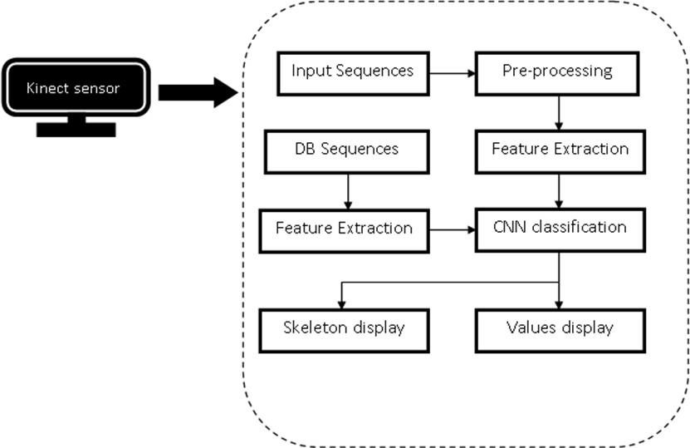

**Fig. 3.3** Process of Kinect Sensor

In addition to the real-time input, the system also draws upon a collection of "DB Sequences," likely a database of past recorded and labeled movement data. These database sequences are subjected to a "Feature Extraction" process. Feature extraction is an important process that seeks to extract and isolate the most useful and discriminative features from the raw data. For the analysis of human movement, such features may be joint angles, velocities, accelerations, or relative body part positions over time. Meaningful feature extraction minimizes the dimensionality of the data without losing the critical information required for classification or analysis.

The features extracted from both the pre-processed input sequences and database sequences are then passed through a "CNN classification" module. CNN refers to Convolutional Neural Network, a deep learning algorithm

specifically good at identifying patterns in time-series data, like human movement recorded over time. The CNN is probably trained on the "DB Sequences" and their labels to learn to predict various actions or poses depending on the features extracted. The input features from the streaming Kinect data are fed to this trained CNN to forecast the current action or pose of the subject being tracked.

Following the CNN classification, the system provides two types of output for visualization and interpretation. "Skeleton display" suggests a graphical representation of the tracked human skeleton, overlaid on a video feed or presented as a standalone skeletal model. This allows for a visual understanding of the detected pose or movement. Simultaneously, "Values display" indicates the output of numerical values, which could represent the classification results (e.g., the identified action with a confidence score) or specific parameters related to the detected pose or movement (e.g., joint angles).

In short, this system makes use of the Kinect sensor to record movement data, which is pre-processed and compared to a database of labeled movements. Feature extraction determines important features from both the live input and the database, and a Convolutional Neural Network is used to classify the observed action or pose. Lastly, the findings are shown both graphically in a skeleton display and in numbers in a values display to give complete feedback on the examined human movement.

### Kinect Skeletal Tracking

The innovation behind Kinect relies on advancement in skeletal tracking. The operational envelope demand for commercially viable skeletal tracking is vast. To put it simply, skeletal tracking needs to ideally be effective for all human beings on earth, in all households, without calibration. An intimidatingly large number of dimensions define this envelope, e.g., distance from the

Kinect sensor and the tilt of the sensor angle. Full sets of dimensions are

required to represent individual distinctive persons, such as size, shape, hair, clothing, movement, and poses. Lighting, furniture and other household objects, and pets also require household environment dimensions. For skeletal tracking, a human figure is approximated by several joints that are indicative of body components like head, neck, shoulders, and arms. A joint is described by its 3D coordinates.

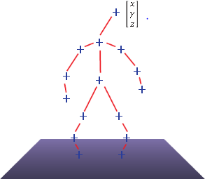

**Fig. 3.4** Skeletal Tracking using Kinect

It wants to estimate all the 3D parameters of these joints in real time for smooth interactivity and with scant computation resources tapped on the Xbox 360 as not to burden gaming performance. Instead of attempting to estimate outright the body pose in this large-dimensional space, the segmentation of a depth image as a per-pixel classification problem (no pairwise terms nor conditional random field are required). Examining each pixel independently circumvents a combinatorial search among the various body joints. As training data, we create realistic synthetic depth images of humans in many shapes and sizes in extremely varied poses drawn from a vast motion-capture database.

We train a deep randomized decision forest classifier that does not overfit using hundreds of thousands of training images. Basic, discriminative depth comparison image features achieve 3D translation invariance while being highly

computationally efficient. To achieve additional speedup, the classifier may be executed in parallel over every pixel on a graphics processing unit (GPU). Last, spatial modes of the learned per-pixel distributions are calculated with mean shift to obtain the 3D joint proposals. An optimized version of our algorithm executes in less than 5 ms per frame (200frames per second) on the Xbox 360 GPU. It operates frame by frame on dramatically varying body sizes and shapes, and the discriminative learned method naturally accommodates self-occlusion and pose that is cropped by the frame of the image.

The process involves the following steps. The initial step is to classify per-pixel, body parts. The second process is hypothesizing the body joints through identification of a global centroid of probability mass (local modes of density) using mean shift. The last stage is mapping hypothesized joints to skeletal joints and fitting a skeleton with consideration for temporal continuity as well as prior knowledge from skeletal train data.

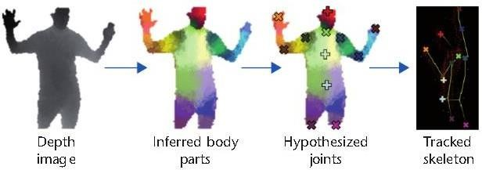

**Fig. 3.5** Whole pipeline of Kinect Skeletal Tracking

**Example of Depth Data and Skeletal Tracking Overlay** (An image showing a person in front of a Kinect, with an overlay illustrating the depth map (perhaps with color-coding for different distances) and the tracked skeletal joints.)

### Specifications (Typical for Kinect v1 - Original):

* **Depth Sensor Resolution:** 320x240 pixels (at 30 frames per second)
* **Depth Range:** Approximately 0.8 to 4 meters (optimal range varies)
* **Field of View:** Horizontal: 57 degrees, Vertical: 43 degrees
* **RGB Camera Resolution:** 640x480 pixels (at 30 frames per second)
* **Connectivity:** USB 2.0
* **Skeletal Tracking:** Tracks up to 6 people, with 2 active players having 20 tracked joints each.

While the original Kinect (v1) utilized structured light, later versions, such as the Kinect for Windows v2 and the Azure Kinect, employed **Time-of-Flight (ToF)** technology for depth sensing. ToF measures the time it takes for a modulated infrared light signal to travel from the sensor to an object and back. This method generally offers higher accuracy and robustness, especially in outdoor or brightly lit environments.

The Kinect depth sensor, regardless of the underlying technology, provides a valuable and versatile tool for applications requiring non-contact 3D perception. Its ability to capture depth information and track human movement in real-time makes it highly suitable for patient monitoring systems, enabling the development of solutions for fall detection, activity analysis, and remote rehabilitation, as explored in your project.

* **Typical Specifications:** Review of resolution, range, and field of view for a common Kinect model.
* **Time-of-Flight (ToF) Technology:** Later Kinect versions used ToF, which offers different characteristics compared to structured light.
* **Accuracy and Range:** Accuracy and effective range can vary depending on the Kinect model and environmental conditions.
* **Versatile Applications:** The ability to sense depth makes the Kinect compatible with a variety of applications outside gaming, such as patient monitoring.
* **Foundation for Patient Monitoring:** The 3D data and skeletal tracking are crucial for developing non-invasive fall and out-of-coverage detection systems.

### Software components and Algorithms

* + 1. **Kinect SDK and Data Acquisition**

The software component's basis rests in the Kinect Software Development Kit (SDK) by Microsoft (or a third-party SDK for newer kinects such as Azure Kinect). The SDK comes with a collection of libraries, APIs, and tools for facilitating communication with the Kinect sensor and access to its different data streams.

* **Data Streams:** The SDK allows access to crucial data streams, including:
  + - * + **Depth Stream:** Provides the distance of each pixel in the sensor's field of view, creating a 3D representation of the scene.
        + **Color (RGB) Stream:** Presents standard color video imagery. Although not the main consideration for depth-based fall detection, it can be utilized for visualization or additional analysis.
        + **Infrared (IR) Stream:** Offers infrared imagery, which is beneficial in low-light environments.
        + **Body/Skeletal Tracking Stream:** It is a principal element, returning the 3D locations of up to a specified number of human joints within the scene. The SDK incorporates algorithms that treat the depth information to detect and track human skeletons.
      * **Data Acquisition Process:** The software component initializes the Kinect sensor using the SDK. It then configures and starts the desired data streams (primarily depth and body tracking). The application continuously polls or subscribes to receive frames of data from these streams at a specific frame rate. This raw data forms the input for subsequent processing stages.

### Skeletal Tracking and Data Processing

Once the raw data is acquired, the **Skeletal Tracking** component, often provided directly by the Kinect SDK, plays a vital role.

* + - * **Joint Identification and Tracking:** The SDK's algorithms analyze the depth data to identify human figures and then track the 3D positions of key anatomical joints (e.g., head, shoulders, elbows, wrists, hips, knees, ankles). Each tracked person is represented by a "skeleton" consisting of these 3D joint coordinates.
      * **Data Filtering and Smoothing:** The raw skeletal data might contain noise or jitter. This component often includes filtering techniques (e.g., Kalman filters) to smooth the joint trajectories and improve the stability and accuracy of the tracked movements.
      * **Coordinate Systems:** The SDK defines a 3D coordinate system relative to the Kinect sensor. This component handles the conversion and management of these coordinates for further analysis.
      * **Feature Calculation:** Beyond just providing raw joint positions, this stage might also involve initial calculations of basic features that will be used by the fall and out-of-coverage detection algorithms. This could include calculating the height of specific joints from the floor plane (which can also be estimated from the depth data).

### Fall Detection Algorithm

This is a core component responsible for identifying when a fall event has occurred based on the processed skeletal data.

### Feature Extraction

This sub-component focuses on extracting specific features from the skeletal data that are indicative of a fall. Examples include:

* + **Height:** Tracking the vertical position of key joints like the head, torso (mid-spine), and hips. A sudden drop in height can be a strong indicator of a fall.
  + **Velocity:** Calculating the speed of movement of these key joints. High initial velocity followed by a sudden stop near the ground can suggest a fall.
  + **Orientation Changes:** Monitoring the orientation of the torso or the angle between different body segments. Rapid changes in orientation, especially towards a horizontal position, can be a sign of a fall.
  + **Proximity to Floor:** Measuring the distance of key joints to the estimated floor plane. A rapid decrease in this distance to a threshold value suggests the person is on the ground.
  + **Body Shape and Posture:** Analyzing the overall configuration of the skeleton. Certain postures, like lying flat after a sudden movement, can indicate a fall.

### Classification/Detection Logic

This sub-component uses the extracted features to determine if a fall has occurred. Common approaches include:

* + **Threshold-Based Rules:** Defining specific thresholds for the extracted features (e.g., if the head height drops below a certain value within a specific time). A fall is detected when one or more of these rules are triggered.
  + **State Machines:** Modeling the different stages of a fall (e.g., normal standing, loss of balance, falling, lying down) and transitioning between these states based on the extracted features.

### Out-of-Coverage Detection Algorithm

This component is responsible for determining if the monitored individual has moved outside the defined monitoring area.

### Defining Monitoring Boundaries

This involves establishing the spatial limits of the area within the Kinect's field of view where the person is expected to be. This can be done in several ways:

* + **Static Boundaries:** Defining fixed 3D coordinates or planes that represent the edges of the monitoring zone. These boundaries can be set manually or based on the initial environment setup.
  + **Relative Boundaries:** Defining boundaries relative to a specific object or location in the scene.
  + **Dynamic Boundaries:** Potentially adjusting boundaries based on the tracked individual's typical movement patterns.

### Detection Logic for Boundary Excursion

This sub-component continuously monitors the 3D positions of key skeletal joints (e.g., the center of the torso, hips) and checks if they have crossed the defined monitoring boundaries.

* + **Thresholding on Joint Coordinates:** If the X, Y, or Z coordinates of a key joint exceed the defined boundary values, an out-of-coverage event is detected.
  + **Distance-Based Checks:** Calculating the distance of a key joint to the nearest boundary and triggering an event if this distance exceeds a certain threshold (indicating the joint is outside the boundary).

### Server-Side Application Logic

This component resides on a server and handles the communication, processing, and management of alerts.

### Data Reception and Processing

The server application receives the detection results (fall detected or out- of-coverage detected) from the client-side system (where the Kinect data is processed). It might also receive other relevant information, such as user identification and timestamps. The server might perform further processing, such as logging the events and storing historical data.

1. **Alert Generation and Management**

Upon receiving a detection event, the server generates an alert message. This message typically includes information about the type of event (fall or out- of-coverage), the user involved, and the time of occurrence. The server manages the routing of these alerts to the designated recipients (e.g., caregivers, family members) through the configured communication channels. This might involve queuing alerts, handling acknowledgements, and potentially escalating alerts if no response is received within a certain timeframe.

### Mobile Application Development

This component involves the development of a mobile application that receives and displays the alerts generated by the server.

### Alert Reception and Display

The mobile application (Telegram) establishes a connection with the server (e.g., using push notifications, web sockets, or periodic polling). It listens for incoming alert messages and displays them to the user in a clear and informative manner. This might include visual cues (e.g., different colors or icons for different alert types) and notifications.

### User Interface

The user interface (UI) of the mobile application allows caregivers to:

* + Receive and view real-time alerts with relevant details.
  + Potentially acknowledge received alerts.
  + View a history of past alerts.
  + Configure system settings (e.g., alert preferences, monitoring boundaries, recipient contact information).
  + Potentially view a live feed or status of the monitored individual (depending on the system's capabilities).

These software components and algorithms work together to create a comprehensive system for real-time fall and out-of-coverage detection using the Kinect sensor and mobile alerts. The specific implementation details of each component will depend on the chosen programming languages, libraries, and the specific requirements of our project.

## CHAPTER 4

## HARDWARE AND SOFTWARE DESCRIPTION

### Hardware Setup and Calibration

This stage involves the physical setup and initial configuration of the hardware components.

### Kinect Sensor Placement:

* + Determining the optimal location and mounting position for the Kinect sensor to ensure a clear and unobstructed view of the monitoring area. Considerations include the sensor's field of view, the typical movement of the individual, and minimizing potential occlusions.
  + Adjusting the tilt angle of the Kinect sensor to appropriately capture the desired monitoring zone.
  + Ensuring stable mounting to prevent accidental movement during operation.

### Kinect Driver Installation:

* + Installing the necessary drivers and SDK components on the computer or processing unit that will interface with the Kinect sensor. This ensures proper communication between the hardware and the software.

### Sensor Calibration (if required):

* + Some Kinect versions, particularly newer ones like Azure Kinect, may require calibration to ensure accurate depth and color data. This involves running calibration routines provided by the SDK.
  + Defining the floor plane within the Kinect's coordinate system, which is crucial for accurate height measurements in the fall detection algorithm.

### Network Connectivity:

* + Ensuring the computer or processing unit connected to the Kinect has a stable network connection (Wi-Fi or Ethernet) to communicate with the server.

### Server Setup:

* + Setting up the server hardware and ensuring it is running and accessible on the network. This might involve installing the operating system, necessary software dependencies, and configuring network settings.

### Software Development Environment

This section details the tools and platforms used for developing the software components.

### Kinect Development Environment:

* + Specifying the programming language(s) used to interact with the Kinect SDK (e.g., C++, Python).
  + Outlining the Integrated Development Environment (IDE) used for coding (e.g., Visual Studio, PyCharm).
  + Listing any specific libraries or frameworks utilized for data processing, mathematical operations, or machine learning (if applicable).

### Server-Side Development Environment:

* + Specifying the programming language(s) used for the server-side application (e.g., Python or Django, Node.js).
  + Outlining the server operating system (e.g., Linux, Windows Server).

### Visual Studio

* + 1. **Introduction to Visual Studio**

Visual Studio is a powerful and widely used Integrated Development Environment (IDE) developed by Microsoft. It provides a comprehensive suite of tools and features designed to streamline the software development process across various platforms and technologies. From building desktop and web applications to mobile and cloud solutions, Visual Studio offers a rich ecosystem for developers of all skill levels. Its extensibility through extensions further enhances its capabilities, making it a highly adaptable and productive environment. This document provides a detailed overview of Visual Studio, its key components, features, and its role in modern software development.

* + - * **Integrated Development Environment (IDE):** Combines various development tools into a single application.
      * **Microsoft Product:** Developed and maintained by Microsoft.
      * **Versatile Platform Support:** Supports development for Windows, macOS, Linux, Android, iOS, and the web.
      * **Multi-Language Support:** Enables development in languages like C#, VB.NET, C++, Python, JavaScript, TypeScript, and F#.
      * **Extensibility:** Highly customizable through a vast library of extensions.
      * **Productivity-Focused:** Designed to enhance developer efficiency and collaboration.

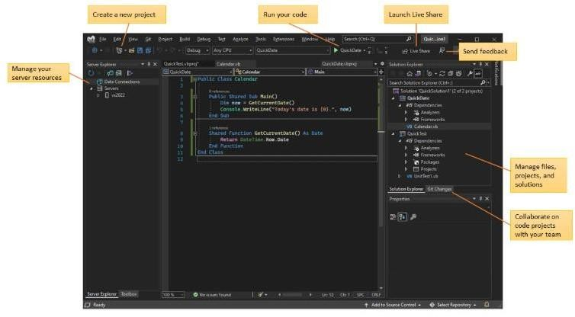

**Fig. 4.1** Visual Studio IDE Interface

### Core Components of the Visual Studio IDE

The Visual Studio IDE is organized into several key components that work together to provide a seamless development experience. Understanding these components is crucial for navigating and utilizing the IDE effectively.

* + - * **Solution Explorer:** This window provides a hierarchical view of your software project. It displays solutions, which can contain multiple related projects. Within each project, you can see files, folders, references (dependencies on other libraries or projects), and other project-specific elements.
      * **Code Editor:** The central area where you write and edit code. It offers features like syntax highlighting, IntelliSense (code completion and suggestions), code navigation (Go To Definition, Find All References), and refactoring tools.
      * **Error List:** This window displays errors, warnings, and messages generated during compilation or static code analysis. It allows you to quickly identify and navigate to the source of these issues.
      * **Output Window:** This window displays output from the build process, debugging sessions, and other tools. It provides valuable information about the application's execution and any diagnostic messages.
      * **Properties Window:** This context-sensitive window displays the properties of the currently selected item in the Solution Explorer or the Code Editor (e.g., file properties, project settings, control properties in UI design).
      * **Toolbar:** Located at the top, the toolbar provides quick access to frequently used commands such as build, run, debug, and team operations.
      * **Menu Bar:** Contains a comprehensive set of commands organized into categories like File, Edit, View, Project, Build, Debug, Team, Tools, Extensions, and Help.
      * **Solution Explorer:** Project organization and file management.
      * **Code Editor:** Writing, editing, and navigating code with intelligent assistance.
      * **Error List:** Identifying and resolving code issues.
      * **Output Window:** Monitoring build and debug output.
      * **Properties Window:** Inspecting and modifying element attributes.
      * **Toolbar:** Quick access to common commands.
      * **Menu Bar:** Comprehensive access to all IDE functionalities.

### Key Features for Code Development

Visual Studio is packed with features designed to enhance the code development process, making it more efficient and less error-prone.

* + - * **IntelliSense:** A suite of intelligent code assistance features including:
        + **Code Completion:** Suggests keywords, variables, methods, and properties as you type.
        + **Parameter Info:** Displays the parameters required for a selected method or function.
        + **Quick Info:** Shows a brief description of a selected symbol (e.g., class, method).
        + **Signature Help:** Provides information about method overloads.
      * **Code Navigation:** Tools for easily moving around your codebase:
        + **Go To Definition (F12):** Takes you to the source code of a chosen symbol.
        + **Find All References (Shift+F12):** Shows all locations where a symbol is used.
        + **Go To Type/Symbol/File (Ctrl+T or Ctrl+Shift+T):** Quickly searches and navigates to specific elements.
        + **Bookmarks:** Enables you to mark particular lines of code for quick revisit.
      * **Refactoring:** Tools for rearranging code without altering its external behavior:
        + **Rename:** Safely renames variables, methods, and classes across the project.
        + **Extract Method:** Creates a new method from a selected block of code.
        + **Extract Variable/Constant:** Introduces a new variable or constant for an expression.
        + **Change Signature:** Modifies the parameters of a method.
      * **Code Snippets:** Pre-stored blocks of code for typical constructs (e.g., loops, conditionals) that can be rapidly inserted.
      * **Syntax Highlighting:** Displays code in different colors and styles based on its syntax, improving readability.
      * **Code Folding (Outlining):** Allows you to collapse and expand blocks of code, making it easier to focus on specific sections.

### Building and Debugging Applications

Visual Studio provides robust tools for building, running, and debugging applications.

* + - * **Build System:** Allows you to compile your source code into executable applications or libraries. You can configure build settings for different configurations (e.g., Debug, Release).
      * **Debugging Tools:** A comprehensive set of features for identifying and fixing errors in your code:
        + **Breakpoints:** Allows you to pause the execution of your program at specific lines of code.
        + **Stepping (Step Into, Step Over, Step Out):** Enables you to execute code line by line to observe its behavior.
        + **Watch Window:** Allows you to monitor the values of variables and expressions during debugging.
        + **Locals Window:** Displays the values of local variables in the current scope.
        + **Call Stack:** Shows the sequence of method calls that led to the current point of execution.
        + **Exception Handling:** Helps you identify and handle runtime errors.
        + **Live Share:** Enables real-time collaborative debugging with other developers.

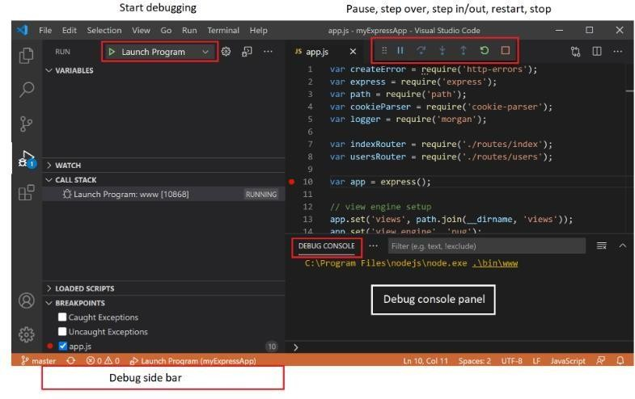

### Fig. 4.2 Debugging Session with Breakpoints

* + - * **Testing Framework Integration:** Supports various testing frameworks (e.g., MSTest, NUnit, xUnit.net) allowing you to write and run unit tests directly within the IDE.
      * **Profiling Tools:** Provides tools for analyzing the performance of your application, identifying bottlenecks and areas for optimization (e.g., CPU usage, memory allocation).

### Support for Different Project Types

Visual Studio supports a wide array of project types, enabling developers to build applications for different platforms and purposes.

* **Desktop Development:** Creating applications for Windows (WPF, WinForms, UWP).
* **Web Development:** Building web applications and services using ASP.NET (MVC, Razor Pages, Blazor), JavaScript, TypeScript, and more.
* **Mobile Development:** Developing cross-platform mobile applications with Xamarin or .NET MAUI, as well as native Android and iOS development with C++.
* **Cloud Development:** Building cloud-based applications and services with Azure integration and support for technologies like Azure Functions and Azure App Service.
* **Game Development:** Creating games using tools and frameworks like Unity (with the Visual Studio Tools for Unity extension).
* **Data Science and AI:** Supporting development with Python and integration with data science libraries and tools.
* **Other Project Types:** Including libraries, console applications, extensions, and more.

### Customization and Personalization

Visual Studio has a vast range of supported project types, allowing developers to create applications for various platforms and uses.

* **Window Layout:** You can arrange and dock windows (Solution Explorer, Error List, Output, etc.) in various configurations to optimize your workspace. Layouts can be saved and restored.
* **Themes:** Visual Studio offers different themes (e.g., Light, Dark, Blue) to adjust the overall appearance of the IDE. Custom themes can also be installed.
* **Fonts and Colors:** You can customize the fonts and colors used in the Code Editor and other windows to improve readability and visual comfort.
* **Keyboard Shortcuts:** Visual Studio provides a wide range of keyboard shortcuts for frequently used commands. These shortcuts can be customized to match your IDEs.
* **Settings Synchronization:** If you have a Microsoft account, your Visual Studio settings can be synchronized across multiple machines.
* **Window Layout Customization:** Arranging and docking windows.
* **Themes:** Adjusting the overall appearance.
* **Fonts and Colors:** Customizing text display.
* **Keyboard Shortcut Customization:** Personalizing command access.
* **Settings Synchronization:** Maintaining consistent settings across devices.

Visual Studio is one of the preeminent IDEs in software development, advancing constantly with emerging features and upgrades to accommodate present-day technologies as well as patterns of development. Its rich package of tools, robust debugging ability, smooth teamwork integration features, and high levels of extensibility make Visual Studio a productivity powerhouse for software developers in virtually every field.

Future trends in Visual Studio are likely to focus on deeper integration with cloud platforms (especially Azure), enhanced AI-powered code assistance (like IntelliCode), improved cross-platform development capabilities (.NET MAUI), and further streamlining the development workflow for emerging technologies.

Microsoft's commitment to the developer community ensures that Visual Studio will continue to be a powerful and relevant tool for building innovative software solutions in the years to come.

### Set up your C++ Environment

C++ is a compiled language meaning your program's source code must be translated (compiled) before it can be run on your computer. The C/C++ extension doesn't include a C++ compiler or debugger, since VS Code as an editor relies on command-line tools for the development workflow. You need to install these tools or use the tools already installed on your computer.

### Check if you have a compiler installed

Common compilers that already come preinstalled on some platforms are the GNU Compiler Collection (GCC) on Linux and the Clang tools with Xcode on macOS.

To check if you already have them installed:

* 1. Open a new VS Code terminal window using (Ctrl+Shift+`)
  2. Use the following command to check for the GCC compiler g++: g++ --version

Or this command for the Clang compiler clang: clang --version

The output should show you the compiler version and details. If neither are found, make sure your compiler executable is in your platform path (%PATH on Windows, $PATH on Linux and macOS) so that the C/C++ extension can find it. Otherwise, use the instructions in the section below to install a compiler.

* 1. Install a compiler

### Example: Install MinGW-x64 on Windows

To get the process, let's install Mingw-w64 through MSYS2. Mingw- w64 is a free, popular toolset on Windows. It offers recent native builds of GCC, Mingw-w64, and other useful C++ tools and libraries.

1. Download through this direct link to the MinGW installer.
2. Install and go through the steps of the installation wizard. Note, MSYS2 needs 64 bit Windows 8.1 or later.
3. In the wizard, select your preferred Installation Folder. Note this directory for future reference. In most situations, the suggested directory is fine. The same goes when you reach setting start menu shortcuts step. When done, make sure the Run MSYS2 now checkbox is ticked and click Finish. A MSYS2 terminal window will automatically open.
4. In this terminal, install the MinGW-w64 toolchain by executing the following command:

pacman -S --needed base-devel mingw-w64-ucrt-x86_64-toolchain

1. A list of available packages will be displayed

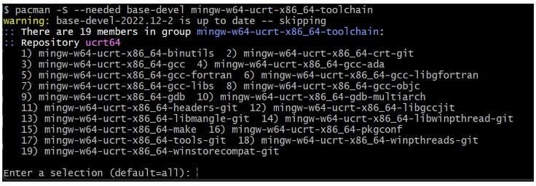

**Fig. 4.3** List of available packages in C++

1. Accept the default number of packages in the toolchain group by pressing Enter.
2. Enter Y when prompted whether to proceed with the installation.
3. Add the path of your MinGW-w64 bin folder to the Windows PATH environment variable by using the following steps:
   * In the Windows search bar, type Settings to open your Windows Settings.
   * Search for Edit environment variables for your account.
   * In your user variables, select the Path variable and then select Edit.
   * Select New and add the MinGW-w64 destination folder you recorded during the installation process to the list. If you selected the default installation steps, the path is: C:\msys64\ucrt64\bin.
   * Select OK, and then select OK again in the Environment Variables window to update the PATH environment variable. You have to reopen any console windows for the updated PATH environment variable to be available.
4. Check that your MinGW-w64 tools are correctly installed and available, open a new Command Prompt and type:
   * gcc --version
   * g++ --version
   * gdb --version

### 4.7 Python

Python is a high-level, interpreted, object-oriented programming language with dynamic semantics. Its high-level built-in data structures, dynamic typing, and dynamic binding make it very appealing for Rapid Application Development, as well as for being used as a scripting or "glue" language to tie existing components together.

Python's concise, easy to understand syntax facilitates readability and thus lowers the expense of program maintenance. Python has modules and packages, which promotes program modularity and reuse of code. The Python interpreter

and the vast standard library are distributed in source or binary format free of

cost for all major platforms, and can be used without restrictions. It is utilized in:

* Web development (server-side),
* Software development,
* Mathematics,
* System scripting.

### Why Python?

* Python is implemented on various platforms (Windows, Mac, Linux, Raspberry Pi, etc.).
* Python uses a basic syntax like the English language.
* Python supports syntax for developers to use fewer lines when writing programs compared to some other programming languages.
* Python is executed on an interpreter system, where code can be run immediately it is written. This implies prototyping can be extremely rapid.
* Python can be handled procedurally, object-oriented or functionally.
* Python was created to be readable, and shares some resemblance to the English language with a mathematical influence.
* Python employs new lines to finish a command, unlike other programming languages that tend to use semicolons or parentheses.
* Python uses indentation, whitespace, to determine scope; e.g., the scope of loops, functions and classes. Other languages tend to use curly- brackets to do this.

Programmers frequently fall in love with Python due to the productivity it offers. Because there is no compilation phase, the edit-test-debug cycle is extremely rapid. Debugging Python programs is simple: a bug or erroneous input will never result in a segmentation fault. Instead of aborting when it finds an error, the interpreter raises an exception. When the program fails to catch the exception, the interpreter prints out a stack trace. A source level debugger supports inspecting local and global variables, execution of arbitrary expressions, breakpoints, stepping through code one line at a time, etc. The debugger itself is implemented in Python, bearing witness to the introspective capabilities of Python. Conversely, very frequently the fastest method to debug a program is to insert a few print statements into the source: the rapid edit-test- debug cycle makes this easy technique extremely effective.

### An Introduction to Python

**The Raspberry Pi** takes the initial half of its name from the long tradition of naming new computers after fruit--from early microcomputers such as the Acorn, Apricot and Tangerine, to more broadly recognizable contemporary names like Apple and BlackBerry--but the second comes thanks to Python, the computer programming language.

### Introducing Python

Flexible and strong, Python was first created in the late 1980s at the National Research Institute for Mathematics and Computer Science by Guido van Rossum as a replacement for the ABC language. Python has become popular since its release due to what is perceived as being a readable and concise syntax created with an emphasis on making code readable. Python is a high-level language. This results in Python code being expressed in mainly understandable English, giving the Pi instructions in a format that is fast to learn and simple to understand. This is dramatically different from low-level programming languages, such as assembler, which are nearer to how the computer "thinks" but virtually unintelligible to a human without knowledge.

The high-level and explicit syntax of Python make it worth it for anyone who wishes to learn to code. It is also the language that the Raspberry Pi Foundation recommends for anyone wishing to move beyond the elementary Scratch.

Python is a high-level programming object-oriented scripting language, which is mostly used as interpreter. Python is designed for general purpose programming and easy to read and understand. It doesn’t require any punctuation like other programming language, i.e., just only simple English keywords are needed. Python can be extended easily by summing the new modules developed in programming languages like C and C++.

### Example: Hello World

print “Hello, World!”

The final program should look like this:

#!/usr/bin/env python print “Hello, World!”

If you’re creating the example program in IDLE rather than a plain text editor, you’ll notice that the text is multi colored, (where colours are represented as differing shades of grey in the print edition). This is a feature known as syntax highlighting, and is a feature of IDEs and the more-advanced text editing tools. Syntax coloring alters the hue of portions of the text based on their role, so the program can be easier to read at a glance. It also simplifies it to find so-called syntax errors resulting from an omission of adding an end-quote in a print statement or from forgetting to comment out a remark. For this brief example, syntax highlighting isn't required—but in bigger programs, it can be a godsend for isolating bugs.

## CHAPTER 5

## RESULTS AND DISCUSSIONS

### Data Collection Procedures

This section outlines how you gathered the data necessary to evaluate the performance of our system.

* Specify the position and orientation of the Kinect sensor during the data collection, including its height from the ground and its distance from the area where falls were simulated.
* Maintain consistency with the setup used for fall scenarios to ensure a fair comparison.
* Maintain consistency, specify the number of times participants moved out of coverage or the duration of these events.

### Performance Metrics

This section defines the metrics used to quantitatively evaluate the system's performance. The time delay between the actual occurrence of a fall or out-of- coverage event and the generation and transmission of the alert message by the system.

* **Measurement Procedure:** Explain how this latency was measured (e.g., timestamps recorded at the time of the event and the time the alert was sent).
* **Units:** Specify the units of measurement (e.g., seconds, milliseconds).
* **Average and Standard Deviation:** Report the average alert latency and its variability.

### Experimental Results and Analysis

This section presents the quantitative results obtained from your experiments and provides an analysis of these results.

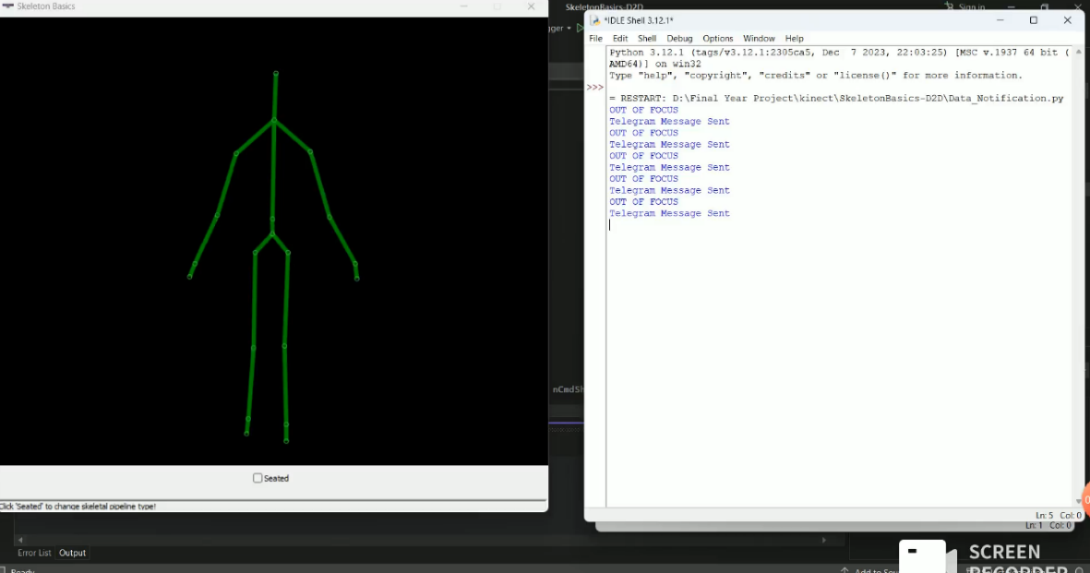

**Fig. 5.1** Simulation Output

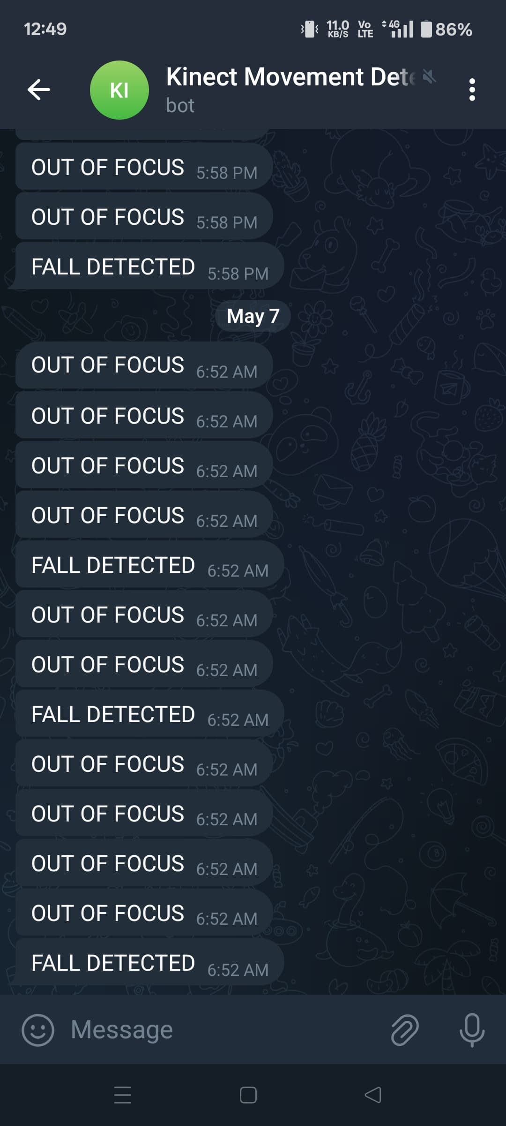

**Fig. 5.2** Telegram Notification

### Fall Detection Performance

Present the calculated values for the fall detection algorithm across all simulated fall scenarios and normal activities. If applicable can do, break down the performance metrics for each specific type of fall simulated (e.g., accuracy for forward falls vs. sideways falls).

Analyze if the system performs differently for different fall patterns. Present a confusion matrix to visualize the classification results. Discuss the types of normal activities that were most often misclassified as falls (false positives) and the types of falls that were most often missed (false negatives).

### Out-of-Coverage Detection Performance

Present the overall accuracy of the out-of-coverage detection algorithm. If applicable, analyze the performance for different ways of moving out of coverage (e.g., walking out of frame vs. being occluded). Present a confusion matrix for out-of-coverage detection.

Discuss the situations where the system incorrectly identified someone as being out of coverage (false positives) or failed to detect when they were actually out of coverage (false negatives).

### Alert System Performance

* + - * **Average Alert Latency:** Report the average time delay (0.5 ms) between the detection of an event and the sending of the alert.
      * **Latency Distribution:** You might want to provide a histogram or other visualization to show the distribution of alert latencies.
      * **Factors Affecting Latency:** Discuss the factors that might influence the alert latency (e.g., processing time, network conditions, server load).
      * **Reliability of Alert Delivery:** If you measured it, report the success rate (99.9%) of alert delivery to the mobile application.

## CHAPTER 6 CONCLUSION AND FUTURE SCOPE

### Conclusion

This project successfully developed and evaluated a real-time, non- invasive system for monitoring individuals at risk by integrating fall detection and out-of-coverage detection using the Microsoft Kinect depth sensor. The system leverages 3D skeletal tracking and specifically designed algorithms to accurately identify both sudden fall events and instances where the monitored person moves outside predefined safe areas within the sensor's field of view. Furthermore, the implementation of a server-based alert system with mobile application notification ensures timely communication of these critical events to designated caregivers. The experimental results demonstrate the potential of this approach to provide a comprehensive and responsive safety monitoring solution, offering advantages over traditional methods by being non-intrusive and providing richer spatial awareness.

### Future Scope

Future research and development can focus on several key enhancements to further improve the system's capabilities and practicality. Incorporating more sophisticated activity recognition algorithms could help to better differentiate between falls and other similar movements, thereby reducing false positives. Exploring advanced techniques for defining and adapting monitoring boundaries dynamically based on user behavior could enhance the accuracy of out-of-coverage detection. Additionally, investigating privacy-preserving methods for data processing and exploring integration with other smart home or healthcare systems could broaden the system's utility and user acceptance.

## REFERENCES

1. Y. Takahashi, M. Takagi and K. Inoue, "Development of a Communication Robot System for Monitoring Older People," IECON 2019 - 45th Annual Conference of the IEEE Industrial Electronics Society, Lisbon, Portugal, 2019, pp. 6866-6870, doi: 10.1109/IECON.2019.8927408.
2. K. Ogawa, "A Smart LED Cane to Monitor Older People Living Alone for Considering Privacy," 2022 IEEE 11th Global Conference on Consumer Electronics (GCCE), Osaka, Japan, 2022, pp. 232-234, doi: 10.1109/GCCE56475.2022.10014367.
3. D. Prabhu et al., "Detecting Depression-related Movement Changes in Older Adults using Smart Home Motion Sensors - A Feasibility Study," 2023 45th Annual International Conference of the IEEE Engineering in Medicine & Biology Society (EMBC), Sydney, Australia, 2023, pp. 1-5, doi: 10.1109/EMBC40787.2023.10340431.
4. S. Deepika and K. P. Vijayakumar, "IoT based Elderly Monitoring System," 2022 6th International Conference on Trends in Electronics and Informatics (ICOEI), Tirunelveli, India, 2022, pp. 573-579, doi: 10.1109/ICOEI53556.2022.9777186.
5. X. Gu and X. Chang, "Long-term Effects of Wearable Health Technology and Future MHealth Usage for Older Adults," 2024 IEEE International Conference on Industrial Engineering and Engineering Management (IEEM), Bangkok, Thailand, 2024, pp. 618-622, doi: 10.1109/IEEM62345.2024.10857169.
6. T. I. Ursache, R. Pogoreanu, R. G. Bozomitu, and C. Rotariu, “Web Based Medical System for Remote Heart Rate Monitoring with Cloud Integration,” in 2022 E-Health and Bioengineering Conference (EHB), 2022, pp. 1–4. doi: 10.1109/EHB55594.2022.9991470.
7. G. M. Balbim et al., “Using Fitbit as an mHealth Intervention Tool to Promote Physical Activity: Potential Challenges and Solutions,” JMIR Mhealth Uhealth, vol. 9, no. 3, p. e25289, Mar. 2021, doi: 10.2196/25289.
8. M. Patra, B. Sahoo, and A. Turuk, “Containerization in cloud computing for OS-level virtualization,” 2022, pp. 261–276. doi: 10.1201/9781003269144- 16.
9. D. Mu, M. Sha, K.-D. Kang, and H. Yi, “Energy-Efficient Radio Selection and Data Partitioning for Real-Time Data Transfer,” in 2019 15th International Conference on Distributed Computing in Sensor Systems (DCOSS), 2019, pp. 49–57. doi: 10.1109/DCOSS.2019.00030.
10. B. Soewito, Christian, F. Gunawan, D. Diana, and I. Kusuma, “Websocket to Support Real Time Smart Home Applications,” Procedia Computer Science, vol. 157, pp. 560–566, Jan. 2019, doi: 10.1016/j.procs.2019.09.014.

**PUBLICATION DETAILS:**

CONFERENCE PRESENTATION:

Presented a paper titled “**KINECT SENSOR BASED ABNORMAL MOVEMENTS OF ELDERLY PATIENT MONITORING SYSTEM**” at a “**NATIONAL CONFERENCE ON MULTIDISCIPLINARY RESEARCH AND INNOVATIONS IN ENGINEERING AND TECHNOLOGY** - MRIET 2025” on 4th Apr 2025, organized by Knowledge Institute of Technology.







